Project 3 – Client Website

# General Description

* Website for a real client
* **Groups:** 1-3 people
* **Due date:** Thursday, June 15th, 2017 (before midnight)
* **The website must be published on Heroku by the due date**

In the final project, you will create a website for a company of your own creation. This is intended to be a capstone project that requires you to synthesize all the skills learned in this class and produce a final product that is a model, high quality website.

# Requirements

## Website plan (5%)

### (2%) Market Analysis

Fill out the Market Analysis

### (1%) Homepage Sketch

A sketch of the website’s home page must be done via Word, PowerPoint or other software, or hand-drawn on paper. The sketch must show the general layout of the website’s homepage, the navigational links, and main content.

### (1%) Website Structure

A sketch of the website’s navigational structure must be done via Word, PowerPoint or other software, or hand-drawn on paper. The website should have at least 12 pages.

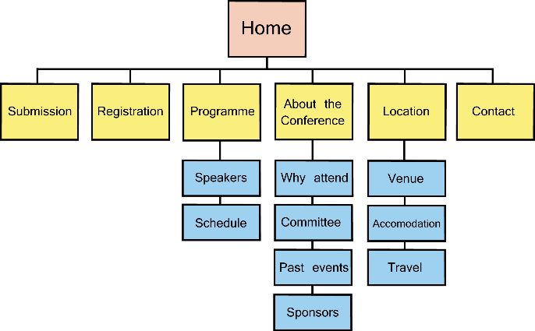

### (1%) Folder Structure

A sketch of the website’s folder structure must be done via Word, PowerPoint or other software, or hand-drawn on paper. You can do a Google image search of “website folder structure”.

## Website content (50%)

### (5%) Images

The website must include at least one image per page. The images must be related to content. The website must also have a logo (on the page header) and an icon (for the browser tab).

### (25%) Pages

The website must include at least 12 content-rich and visually appealing pages.

### (5%) Navigation Menu

The website must include a main navigational menu which will guide the user around the website. The navigational menu must be included in all pages in the site.

### (5%) CSS

The website must use CSS for styling. No styling should be applied inside the .html files.

### (10%) JavaScript

The website must include at least 2 JavaScript features.

## Coding (5%)

Good coding practices must be employed in the website. This includes the following:

* Appropriate indentation (use tab) of all nested elements.
* Opening and closing of all HTML elements (except for empty elements; e.g. <br />).
* Appropriate use of semantic tags (e.g. <main>, <nav>, <article>, etc.).
* Appropriate syntax and indentation of CSS selectors and properties.
* Appropriate use of “class” and “id” for CSS selectors.
* Appropriate coding style in JavaScript

## Evaluation Rubric (40%)

The evaluation rubric we created together in class will be used to evaluate your website. When the websites are completed, the teacher and the students will use this rubric to evaluate each website. 20% of the grade in this section will come from the teacher, and 20% from the students.

